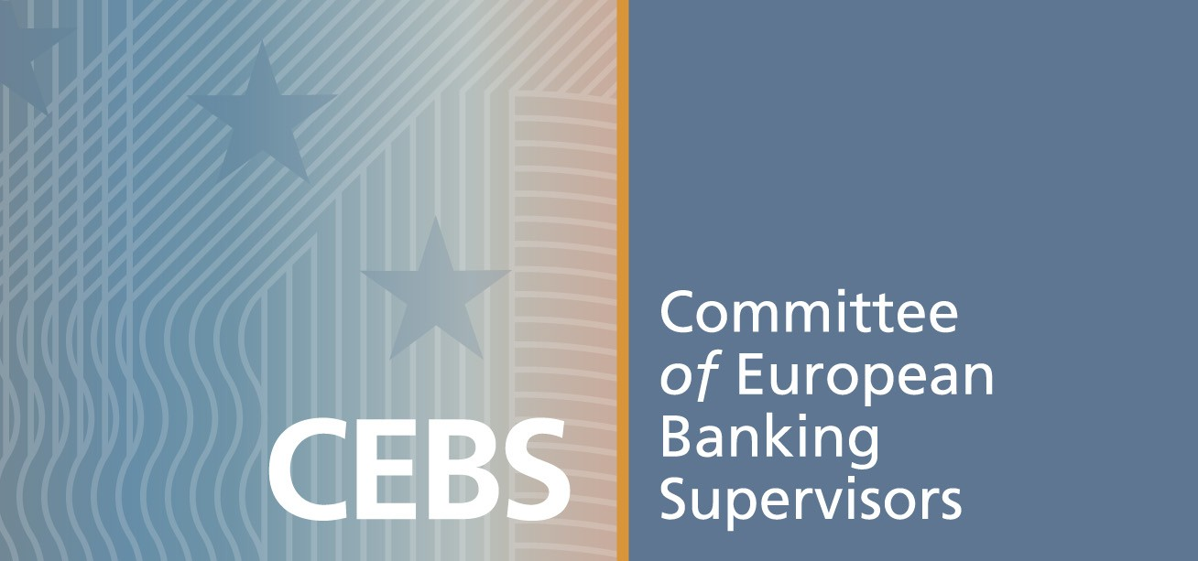
IX European Banking Supervisors XBRL Workshop and Tutorial
29th September - 1st October 2008.
Hosted by la Commission Bancaire. Paris
Application form (to be sent to info@corep.info)

FINAL VERSION

Capacity is limited to 80 seats. Applications received until full book will be immediately confirmed in written, to facilitate travel arrangements. A waiting list will be open when full booked. Attendance is at no cost. A number of seats have been reserved for supervisors. Please find updated agenda, venue and hotel information at www.corep.info/events.html

Organisation type: Supervisor. Bank. Company
Organisation Name: ……………………………………………………………………… Country ………………………

First and Second name: ……………………………………….………………………..Title :…………..……..……
Phone: ………………………………………………e-mail: …………………………………………………………..………
Yes, I will register for: Tutorial 29th-30th noon-noon Workshop 30th-1st noon-noon
Furthermore, I like to attend:
Complimentary Lunch: Sept.30th Non-complimentary Dinner: Sept.29th Sept.30th

First and Second name¹: ……………………………………….………………………..Title :…………..……..……
Phone: ………………………………………………e-mail: ……………………………………………………………..………
Yes, I will register for: Tutorial 29th-30th noon-noon Workshop 30th-1st noon-noon
Furthermore, I like to attend:
Complimentary Lunch: Sept.30th Non-complimentary Dinner: Sept.29th Sept.30th

Voluntary presentation/demo (Please return details in additional document).

I would suggest the change/inclusion of the following topic(s) in the agenda:

Disclaimer: CEBS/Commission Bancaire will assume no responsibility for any damages incurred by your attendance at this event. Your attendance at such event is voluntary and will in no way hold us responsible for any claim arising from your attendance.

Made in ………………………………… on ……. ……………. 2008
(e-mail delivery is equivalent to signature)

 | XBRL Europe Assembly  (All day on 29th) |  |  | CEBS XBRL Tutorial  (From noon, 29th to noon, 30th ) | CEBS XBRL Workshop  (From noon, 30th to noon,1st)
 | Start | End | Duration | Topic | SPEAKER
Monday 2008/09/29
 | 12:00 |  |  | Salons Amphi Pereire open the doors
 | 12:30 | 12:35 | 00:05 | Introduction to Tutorial presentations | CEBS XBRL Network Members
 | 12:35 | 12:55 | 00:20 | Formulae implementation in Bank of Spain | Victor Morilla. Banco de España
 | 12:55 | 13:10 | 00:15 | Formulae in the European FINREP taxonomy | Bernard Darrius. Commission Bancaire, France
 | 13:10 | 15:30 | 02:20 | Tutorial on Formulae | Victor Morilla. Banco de España
 | 15:30 | 16:00 | 00:30 | Coffee break
 | 16:00 | 17:00 | 01:00 | Tutorial on Versioning | Katrin Schmhel. Bundesbank
 | 17:00 | 18:00 | 01:00 | Tutorial on Best Practices | Ignacio Boixo. Banco de España
Tuesday 2008/09/30
 | 09:00 | 09:15 | 00:15 | Example of codification system of taxonomy elements | Jérôme Poupard. Commission Bancaire, France
 | 09:15 | 10:15 | 01:00 | Tutorial on Matrix Schema | Michele Romanelli. Banca d’Italia
 | 10:15 | 10:30 | 00:15 | Open Source XBRL Initiatives | Eduardo González. FIDESOL
 | 10:30 | 11:00 | 00:30 | Coffee break
 | 11:00 | 11:05 | 00:05 | Words of Welcome | Jean-Luc Menda. Commission Bancaire
 | 11:05 | 11:45 | 00:40 | XBRL Europe: An Introduction for Supervisors | Jean-Luc Menda (Vice-Chairman)  Gilles Maguet (Secretary General)
 | 11:45 | 12:30 | 00:45 | Open discussion & conclusions on Tutorials | Open participation is kindly encouraged
 | 12:30 | 13:30 | 01:00 | Lunch
 | 13:30 | 13:35 | 00:05 | Workshop presentation | CEBS XBRL Network Members
 | 13:35 | 14:30 | 00:55 | Evolution of COREP and FINREP | Wolfgang Strohbach (CEBS) and Ignacio Boixo
 | 14:30 | 15:30 | 01:00 | IFRS taxonomy: Present and Future | Maciej Piechocki, IASCF
 | 15:30 | 16:00 | 00:30 | Coffee break
 | 16:00 | 17:00 | 01:00 | Banking presentation: implementing XBRL in a cross-border group | Philippe Leys and Derek De Brandt, FORTIS
 | 17:00 | 18:00 | 01:00 | Practical aspects of COREP and FINREP implementation with XBRL | Michal Piechocki, XBRL Poland
Wednesday 2008/10/01
 | 09:00 | 09:45 | 00:45 | Guest Speech: XBRL implementation in the Reserve Bank of India | Dr. Ramasastri and Mr. Ravimohan, RBI
 | 09:45 | 10:30 | 00:45 | XBRL in the Dutch Central Bank | T.A. Staneke, DNB
 | 10:30 | 11:00 | 00:30 | Coffee break
 | 11:00 | 11:45 | 00:45 | SURFI: Future French Banking Supervision with XBRL | Jean-Luc Menda and Sylviane Delarue.  Commission Bancaire, France
 | 11:45 | 12:30 | 00:45 | Open discussion & conclusions on Workshop | Open participation is kindly encouraged
 | 12:30 |  |  | End of the IX Workshop

Please refer the person who will attend the session as the invitation is strictly personal.
Supervisors and Banks are kindly invited to show their projects and solutions.

